Welcome to Week 9!

Executive presence is a crucial competency for every HR professional, as it significantly impacts your ability to engage confidently with senior leaders and connect meaningfully with individual employees. Regardless of the audience, you want others to pay attention, trust your judgment, and view you as a credible partner. While executive presence can absolutely be learned, it requires intentional practice. Put yourself in situations that stretch your comfort zone, confront the fears that hold you back, and continually refine how you present yourself. Your career will be stronger and your impact far greater as a result.

Deliverables for the week:

- Complete the required readings and videos as outlined in Week 9.
- ﻿﻿Complete your DQ requiring an initial post by Wed, midnight in your time zone, and respond to the posts of at least two peers respond to the posts of at least two peers by Monday, 9:00 am (eastern), Week 10.
- Watch the Success Factors video on Assignment 4.
- Assignment 4, Managing Conflicts and Confidences, is due Monday, 9:00 am (eastern), Week 10. This is a Zoom presentation; no written work is required! Be sure to use the scenario provided in the course shell.
- Complete the End of Course Survey. I ask you for your feedback.

Do not hesitate to phone/email/text me if there are issues! I am here for YOU! Please take a moment to view my Weekly Insights video below (if you are viewing this from the course shell.) If you are reading this announcement from your email, you can navigate to the video by cutting and pasting the following URL into your web browser: https://bit.ly/week9522

Here is the weekly highlights podcast:

Here is a new feature! The weekly infographic of this week’s themes!

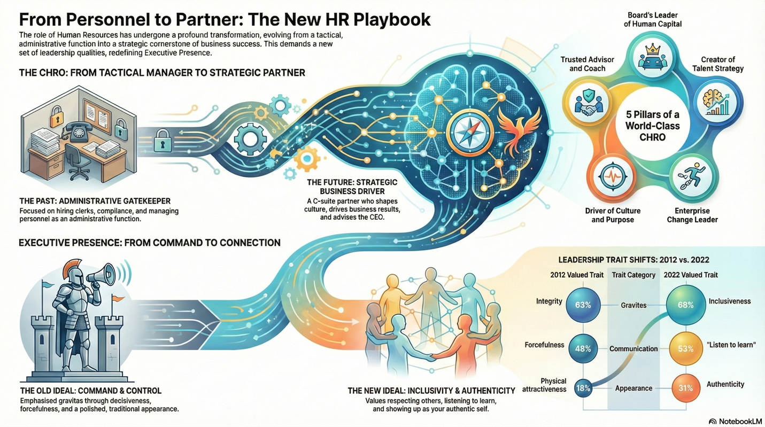

See you in the classroom!

Dr. W

Dr. Richard “Rick” Wallace, DSc
Full Professor
HR Concentration Lead
Email: richardb.wallace@jwmi.com (JWMI)
rickwallace73@gmail.com (personal)
Cell Phone or text: 636-357-5235
Home phone: 919-322-2585

